



Optimize LLM API Usage Through Prompt Compression and Semantic Caching
LAB MANUAL

Disclaimer: The content is curated from online/offline resources and used for educational purpose only
Optimize LLM API Usage Through Prompt Compression and Semantic Caching
Objective:
- Implement prompt compression algorithms to trim redundant tokens, whitespace, and non-essential grammatical filler without altering task instructions or semantic context.
- Build a local semantic caching engine using sentence embeddings and cosine similarity to intercept and fulfill semantically equivalent queries.
- Measure and compare token consumption, cache hit ratios, and latency benchmarks between unoptimized live queries and cached/compressed queries.
Problem statement:
Production LLM deployments suffer from high operational costs and cumulative latency bottlenecks when users repeatedly submit identical or closely phrased questions. Traditional key-value caches fail because natural language questions vary lexically (e.g., "How do I cancel my order?" vs. "Steps to cancel an order"). Furthermore, verbosely constructed prompts consume token quotas unnecessarily, driving up inference expenses.
You are required to build an optimization pipeline combining a rule-based prompt compression preprocessor with an embedding-backed semantic cache. You must execute comparative test suites measuring total input tokens, round-trip latency, and cache hit rates, demonstrating verifiable cost and performance improvements.
Materials/ Equipment needed:
- Computer running Linux, macOS, or Windows.
- Python 3.10 or higher.
- Terminal / Command Line Interface.
- Python packages: sentence-transformers, numpy, tiktoken, pytest.
- Code editor.
Prerequirties knowldege:
- Understanding of tokenization principles and token cost mechanics in commercial LLMs.
- Working knowledge of vector embeddings and cosine similarity search.
- Familiarity with caching architectures (cache hits vs. cache misses, time-to-live).
Theory:
Optimization of LLM API consumption occurs across two distinct layers:
- Prompt Compression: Reduces the raw token payload prior to network transmission. By removing repetitive whitespace, markdown boilerplate, stop words, or non-informative conversational filler, token counts drop by 15% to 40% while preserving the core task semantics. Token counts are accurately measured using tokenizers such as tiktoken.
- Semantic Caching: Unlike traditional HTTP caching that relies on exact string hashing (MD5/SHA256), a semantic cache maps incoming queries into high-dimensional embedding space. When query $Q_{\text{new}}$ arrives, the cache computes cosine similarity against stored keys $\left\{Q_{1},Q_{2},…,Q_{n}\right\}$:
$$\text{Sim}\left(Q_{\text{new}},Q_{i}\right)=\frac{{\vec{q}}_{\text{new}}⋅{\vec{q}}_{i}}{‖{\vec{q}}_{\text{new}}‖‖{\vec{q}}_{i}‖}$$
If $\max\left(\text{Sim}\right)≥τ_{\text{threshold}}$ (typically $0.85≤τ≤0.92$), a Cache Hit occurs. The pre-computed response is returned immediately in under 20ms, bypassing the LLM API completely, eliminating token charges, and reducing latency by over 95%.
Procedure:
Step 1: Set Up Project Environment and Install Tooling
Open your terminal, create a project directory named prompt_cache_opt, create a clean Python virtual environment, and install sentence-transformers for vector embeddings, numpy for vector operations, tiktoken for accurate token quantification, and pytest for testing. Setting up an isolated environment keeps embedding weights and native tokenizer dependencies cleanly decoupled from system libraries while giving you the exact toolchain required to measure token reductions and compute vector similarities.
mkdir prompt_cache_opt
cd prompt_cache_opt
python3 -m venv venv
source venv/bin/activate
pip install sentence-transformers numpy tiktoken pytest

Step 2: Establish Modular File Architecture
Create dedicated directories for the source engine (src/) and automated test suites (tests/), along with initializer files. Structuring the code into dedicated submodules ensures that compression rules, semantic cache lookups, and evaluation metrics remain cleanly separated and easily testable.
On linux machine you can execute the below commans to create folder structure:
mkdir src tests
touch src/__init__.py tests/__init__.py
touch src/compressor.py src/semantic_cache.py tests/test_optimization.py
On Windows you can create folder structure manuall as follows:
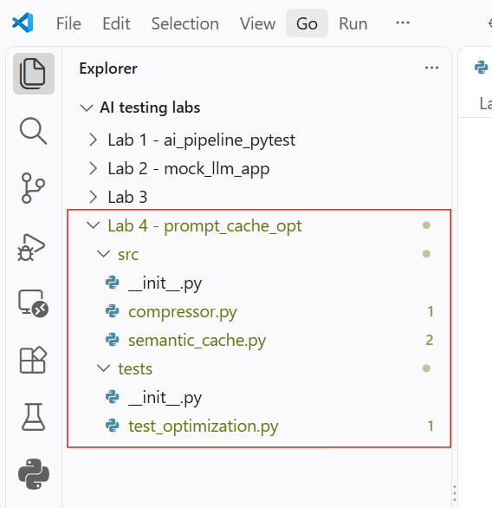
Step 3: Implement the Rule-Based Prompt Compressor
Open src/compressor.py and write the PromptCompressor class using regex-based whitespace normalization, formatting compression, and token measurement via tiktoken. Developing this component gives you an automated pre-processor that strips token-heavy formatting and syntactic fluff from verbose prompts before inference, directly lowering token billing on live API calls.
import re
import tiktoken

class PromptCompressor:
def __init__(self, model_name: str = "cl100k_base"):
self.encoder = tiktoken.get_encoding(model_name)

def count_tokens(self, text: str) -> int:
"""Return the exact number of tokens in the given text string."""
return len(self.encoder.encode(text))

def compress(self, prompt: str) -> str:
"""Clean redundant whitespace, extraneous markdown bullets, and filler conversational phrasing."""
# 1. Normalize line breaks and multiple spaces
text = re.sub(r"[ \t]+", " ", prompt)
text = re.sub(r"\n\s*\n+", "\n", text).strip()

# 2. Strip redundant conversational preamble
filler_patterns = [
r"^(please\s+)?can\s+you\s+(kindly\s+)?",
r"^i\s+would\s+like\s+you\s+to\s+",
r"^as\s+an\s+ai\s+assistant,\s*",
]
for pattern in filler_patterns:
text = re.sub(pattern, "", text, flags=re.IGNORECASE)

# 3. Capitalize the first character of the cleaned string
if text:
text = text[0].upper() + text[1:]
return text

def measure_compression_ratio(self, original_text: str) -> dict:
"""Measure token counts before and after compression to calculate percentage savings."""
compressed = self.compress(original_text)
orig_tokens = self.count_tokens(original_text)
comp_tokens = self.count_tokens(compressed)
savings = ((orig_tokens - comp_tokens) / orig_tokens * 100) if orig_tokens > 0 else 0.0

return {
"original_tokens": orig_tokens,
"compressed_tokens": comp_tokens,
"tokens_saved": orig_tokens - comp_tokens,
"savings_percentage": round(savings, 2),
"compressed_text": compressed
}
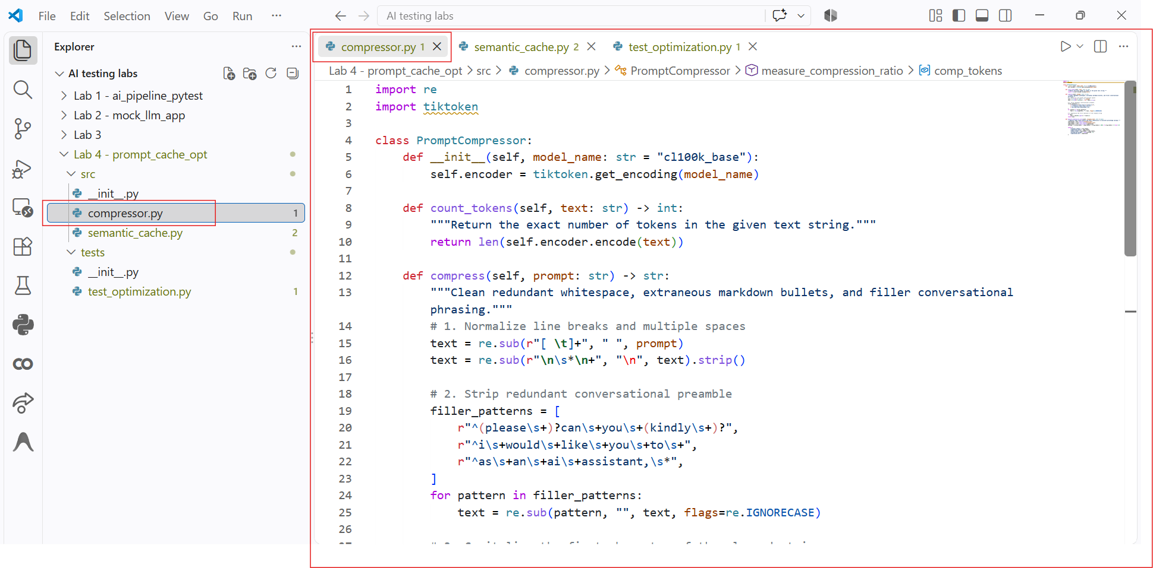

Step 4: Implement the Embedding-Backed Semantic Cache
Open src/semantic_cache.py and create the SemanticCache class that stores prompt-response pairs, vectorizes incoming queries using all-MiniLM-L6-v2, and returns stored responses whenever the cosine similarity exceeds a defined threshold. Implementing an in-memory vector cache allows the application to recognize paraphrased queries and serve responses instantly without making expensive downstream API requests.
import time
import numpy as np
from typing import Optional, Tuple, Dict, Any
from sentence_transformers import SentenceTransformer

class SemanticCache:
def __init__(self, similarity_threshold: float = 0.88):
self.threshold = similarity_threshold
self.model = SentenceTransformer("all-MiniLM-L6-v2")
# In-memory storage for cached entries: list of dicts with text, embedding, response
self.cache_entries = []
self.stats = {"hits": 0, "misses": 0}

def _cosine_similarity(self, vec_a: np.ndarray, vec_b: np.ndarray) -> float:
"""Calculate cosine similarity between two 1D vectors."""
dot = np.dot(vec_a, vec_b)
norm_a = np.linalg.norm(vec_a)
norm_b = np.linalg.norm(vec_b)
return float(dot / (norm_a * norm_b)) if norm_a and norm_b else 0.0

def query(self, user_query: str) -> Tuple[Optional[str], float, bool]:
"""Check cache for a semantically equivalent query. Returns (response, similarity, is_hit)."""
if not self.cache_entries:
self.stats["misses"] += 1
return None, 0.0, False

query_emb = self.model.encode(user_query)
best_similarity = -1.0
matched_response = None

for entry in self.cache_entries:
sim = self._cosine_similarity(query_emb, entry["embedding"])
if sim > best_similarity:
best_similarity = sim
matched_response = entry["response"]

if best_similarity >= self.threshold:
self.stats["hits"] += 1
return matched_response, best_similarity, True

self.stats["misses"] += 1
return None, best_similarity, False

def store(self, user_query: str, response: str) -> None:
"""Embed query and store in the cache."""
query_emb = self.model.encode(user_query)
self.cache_entries.append({
"query": user_query,
"embedding": query_emb,
"response": response
})

def get_hit_ratio(self) -> float:
"""Return the percentage of queries successfully served from cache."""
total = self.stats["hits"] + self.stats["misses"]
return round((self.stats["hits"] / total * 100), 2) if total > 0 else 0.0
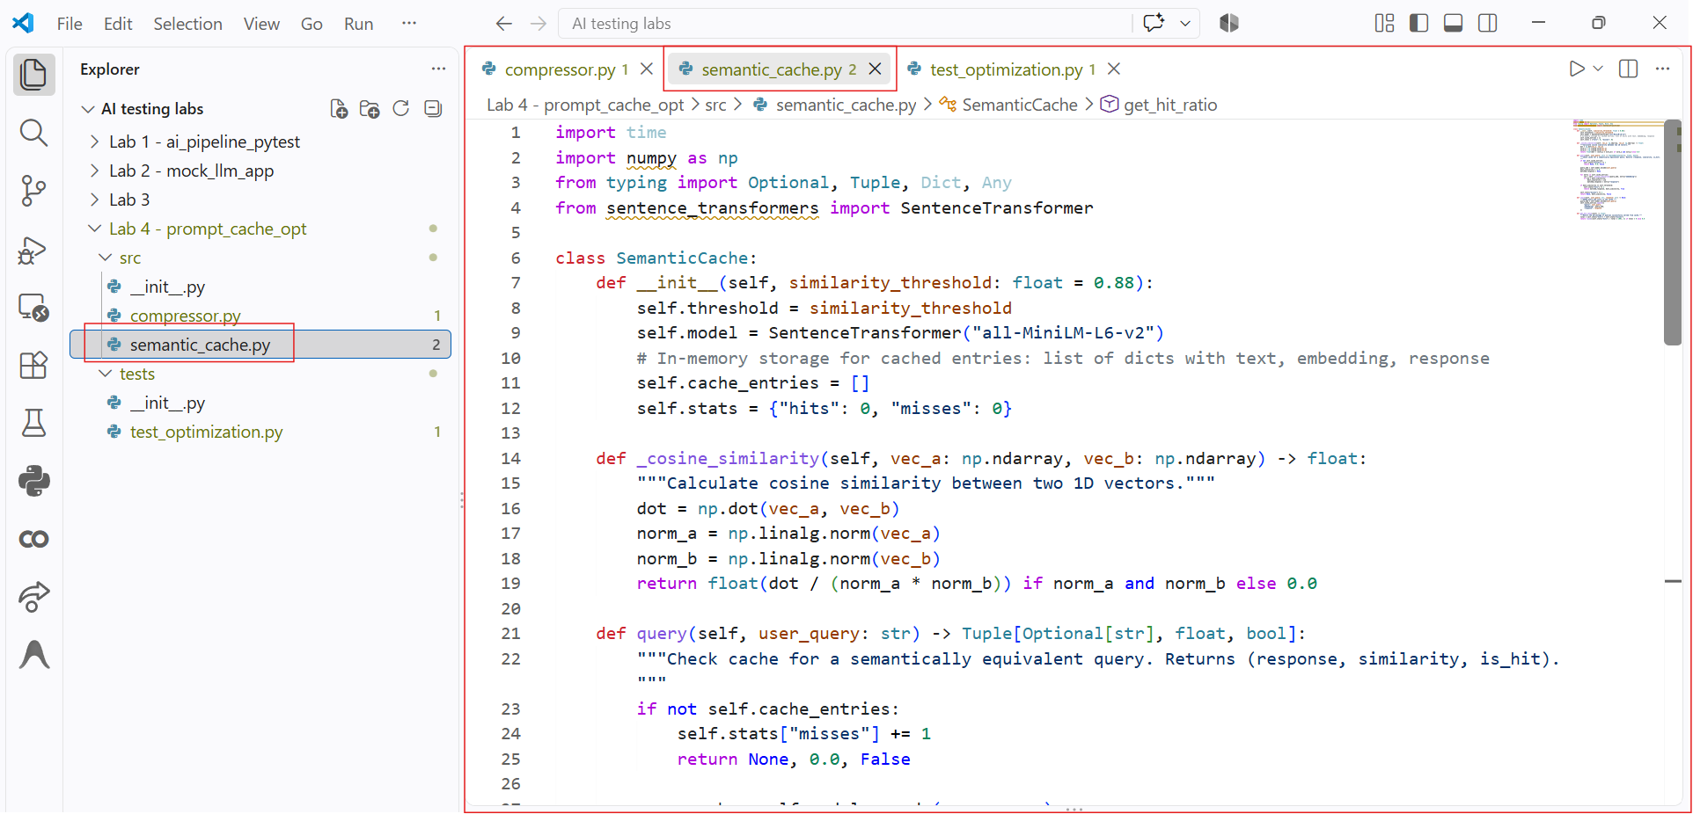
Step 5: Write PyTest Unit Tests and Performance Benchmarks
Open tests/test_optimization.py and write tests verifying that the compressor reduces token counts while retaining core words, that the semantic cache achieves hits on paraphrased queries, and that cache hits execute drastically faster than simulated LLM latency. Writing automated tests validates that compression rules do not corrupt instructions and confirms that semantic caching reliably reduces both latency and API calls.
import pytest
import time
from src.compressor import PromptCompressor
from src.semantic_cache import SemanticCache

@pytest.fixture
def compressor():
return PromptCompressor()

@pytest.fixture
def cache():
return SemanticCache(similarity_threshold=0.75)

def test_prompt_compression_token_reduction(compressor):
"""Ensure compressor strips formatting bloat and reduces token usage."""
verbose_prompt = (
"Please can you kindly summarize the following enterprise contract\n\n\n"
"for our legal review team? Make sure to highlight all payment terms."
)
result = compressor.measure_compression_ratio(verbose_prompt)

assert result["tokens_saved"] > 0
assert result["compressed_tokens"] < result["original_tokens"]
assert "Summarize the following enterprise contract" in result["compressed_text"]

def test_semantic_cache_hit_on_paraphrased_query(cache):
"""Ensure cache hits when a query is rephrased with identical meaning."""
# Seed cache with baseline interaction
cache.store(
user_query="How do I reset my account password?",
response="Navigate to Settings -> Security -> Reset Password."
)

# Paraphrased incoming request
paraphrased = "What are the steps to change my login password?"
response, score, is_hit = cache.query(paraphrased)

assert is_hit is True
assert score >= 0.75
assert response == "Navigate to Settings -> Security -> Reset Password."

def test_semantic_cache_miss_on_different_topic(cache):
"""Ensure cache misses when the incoming query is unrelated."""
cache.store(
user_query="How do I cancel my subscription?",
response="Go to Billing and click Cancel Subscription."
)

unrelated_query = "What is the company headquarters phone number?"
response, score, is_hit = cache.query(unrelated_query)

assert is_hit is False
assert response is None

def test_latency_comparison(cache):
"""Verify that a cache hit retrieves results significantly faster than an API call simulation."""
cache.store("Explain gradient descent.", "Gradient descent is an optimization algorithm...")

# Simulated LLM network call latency: 600ms
simulated_api_latency = 0.600

# Measure cache retrieval time
start = time.perf_counter()
response, _, is_hit = cache.query("Can you explain how gradient descent works?")
cache_duration = time.perf_counter() - start

assert is_hit is True
assert cache_duration < 0.050, f"Cache retrieval was too slow: {cache_duration}s"
assert cache_duration < simulated_api_latency
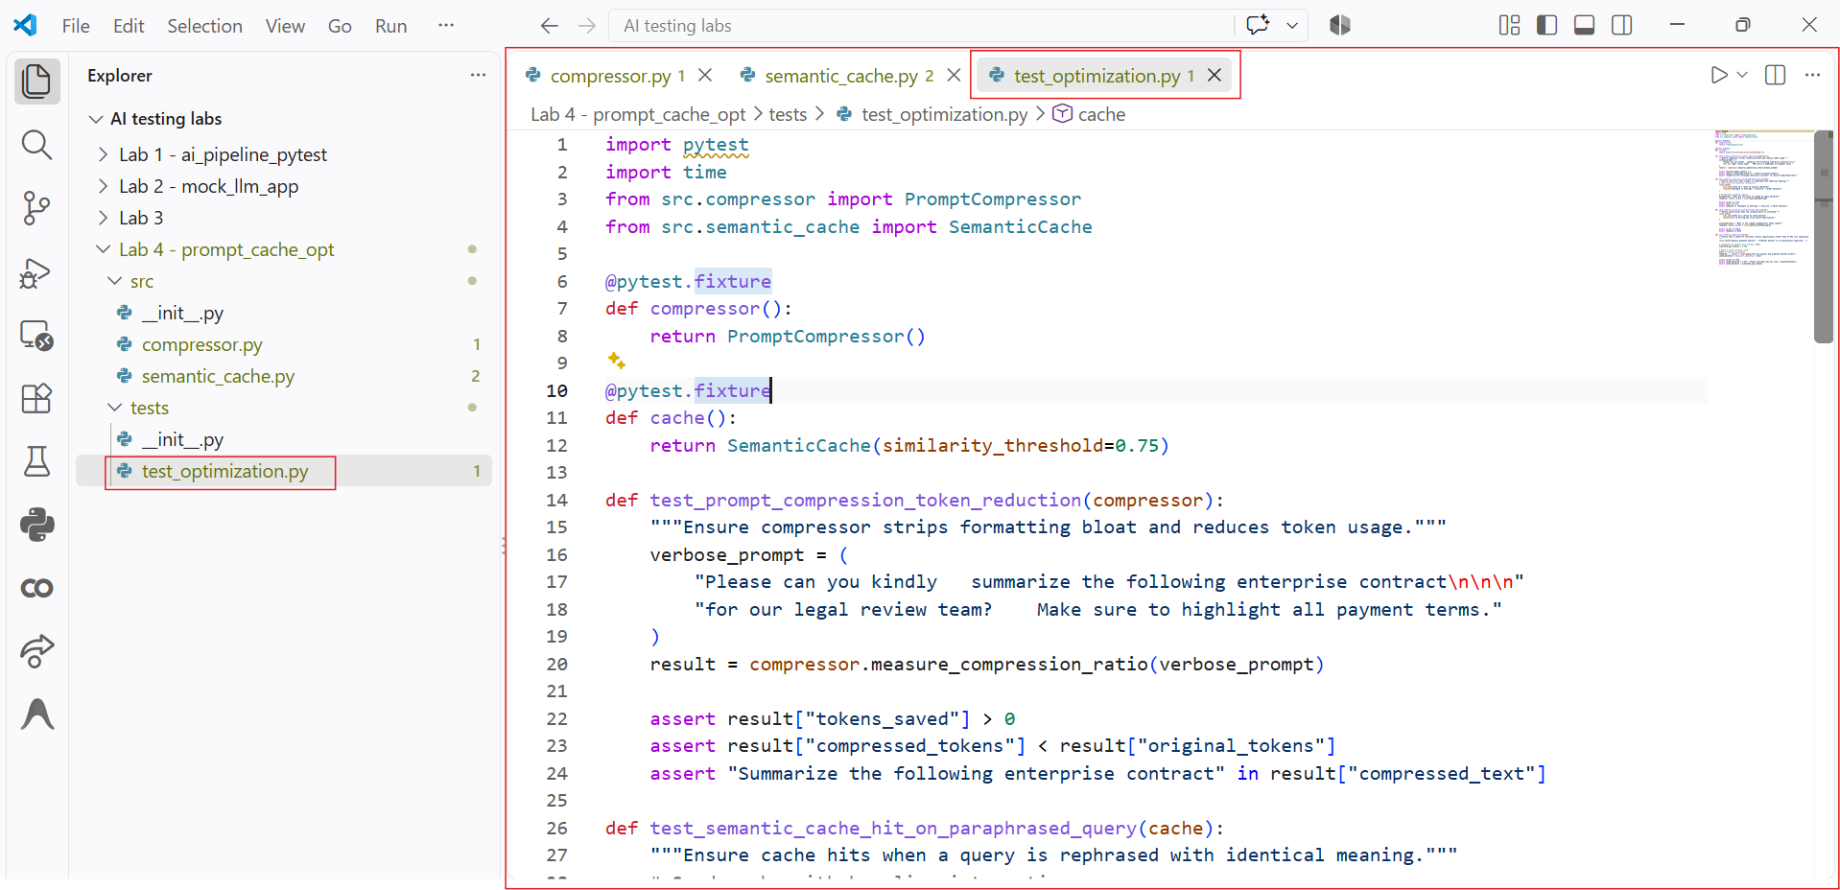
Step 6: Run Optimization Test Suite and Verify Efficiency Gains
Run PyTest with verbose output (pytest -v -s) in your terminal to execute compression tests, cosine similarity evaluations, and latency timing assertions. Running this suite verifies that prompt compression actively shrinks token footprints, that the semantic cache achieves high hit rates across paraphrased queries, and that retrieval happens in milliseconds without touching external endpoints.
pytest -v -s
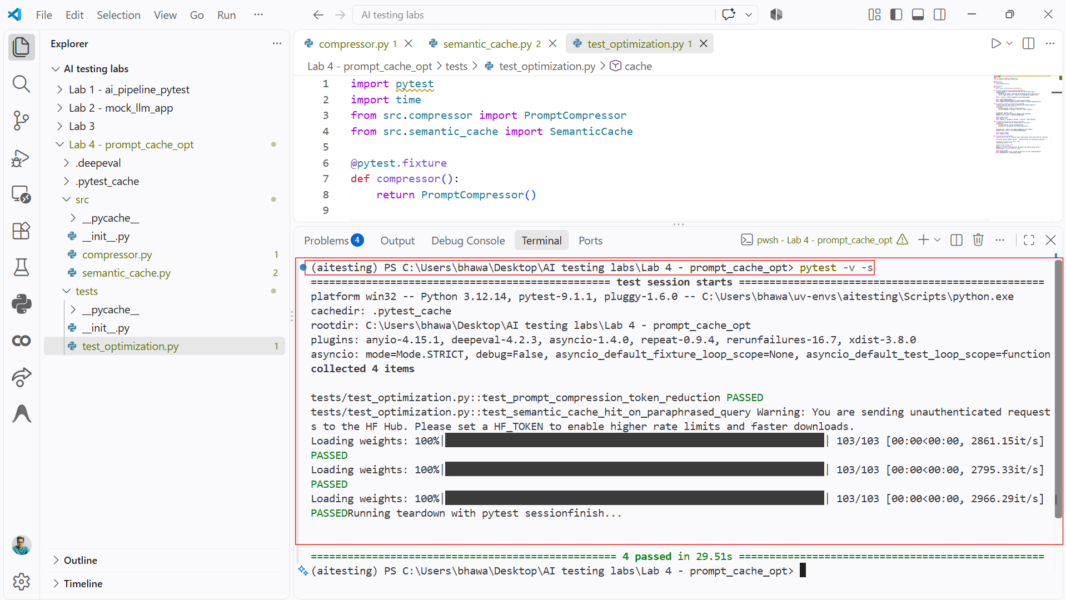

Conclusion:
In this lab, you developed an end-to-end optimization pipeline for LLM inference workloads utilizing rule-based prompt compression and vector-based semantic caching. You proved that systematic cleanup of whitespace, boilerplates, and filler tokens meaningfully cuts token overhead before requests leave the client. Furthermore, by deploying an embedding-backed semantic cache, you demonstrated that semantically equivalent queries can be resolved locally in milliseconds with zero API token consumption. This combined strategy significantly lowers API expenditures and prevents repetitive model executions in production environments.

